Lucas Swanson
4/20/2025
Software Engineering Methods
Exercise 3.4
Steps for a merge conflict:
- First step we need to do is to create a repository for creating the conflict and create a “main” branch:
  - 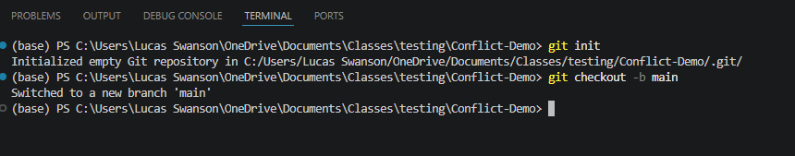
  - 
- Then we need to create the first two javascript files, and commit them to main:
  - 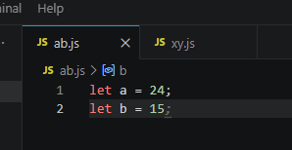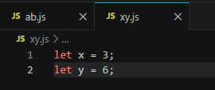
  - 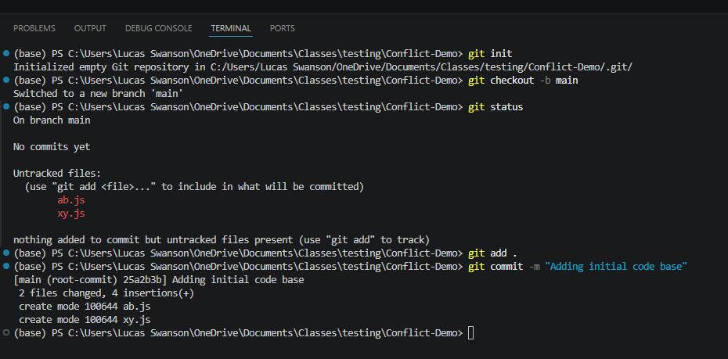
  - 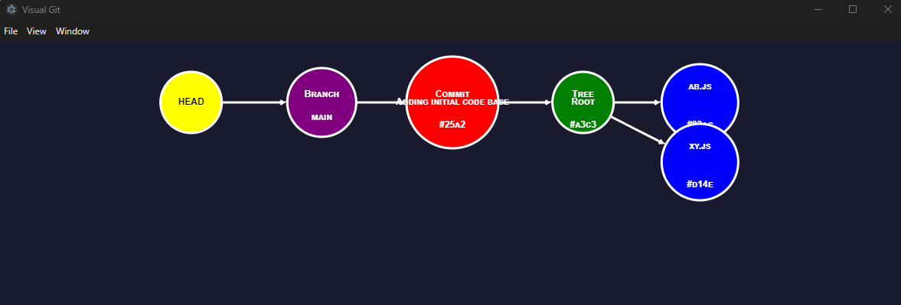
- At this point you should see your branch “main”, with one commit that points to two files, ab.js and xy.js. We will now need to create two different feature branches. One will be “FeaturePat”, the other “FeatureKris”. Note: You MUST swap back to main each time you make a branch because it will use that as the base every time you create a branch unless otherwise specified!
  - 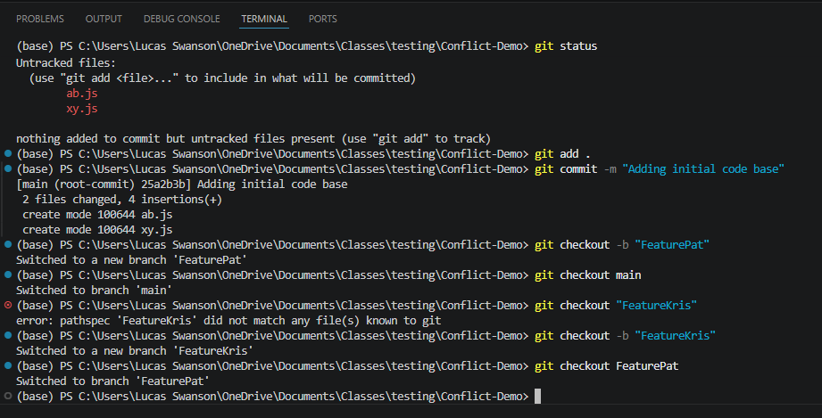
  - 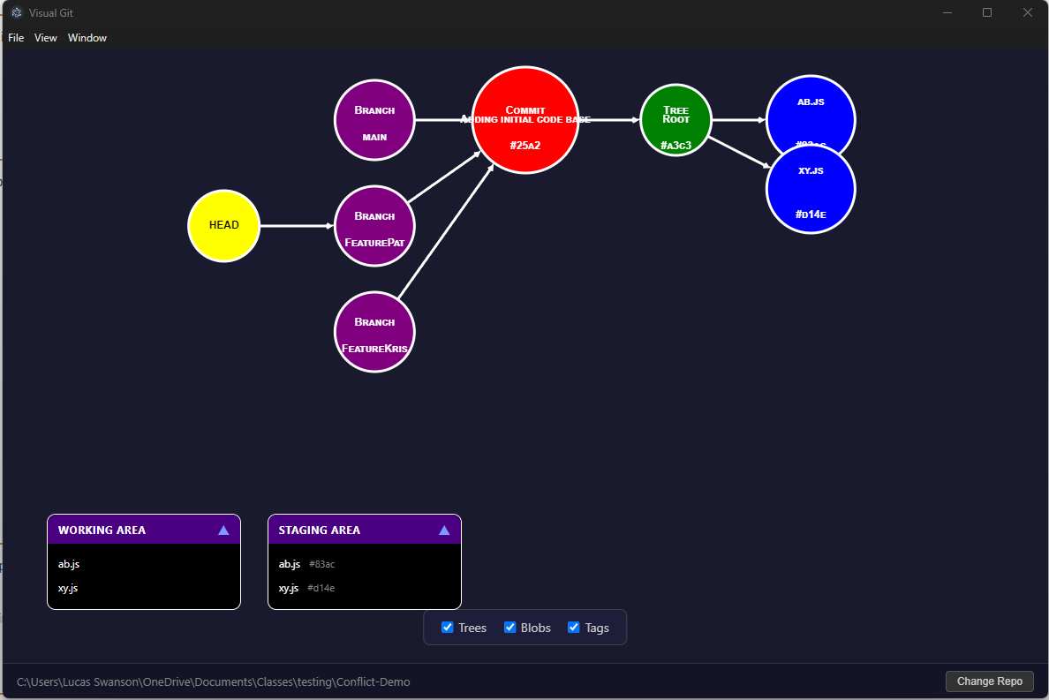
- Now that we have these, we are going to make a few modifications for Pat. Pat will delete ab.js and change x to value 2 in xy.js, then commit these changes:
  - 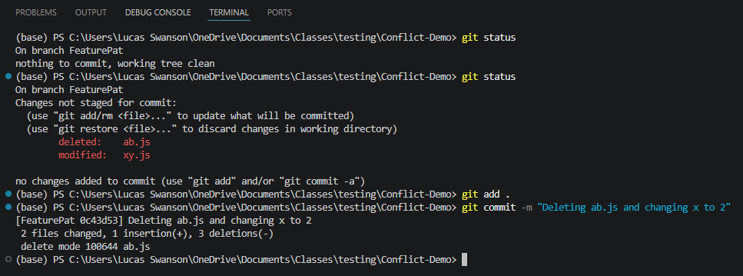
  - 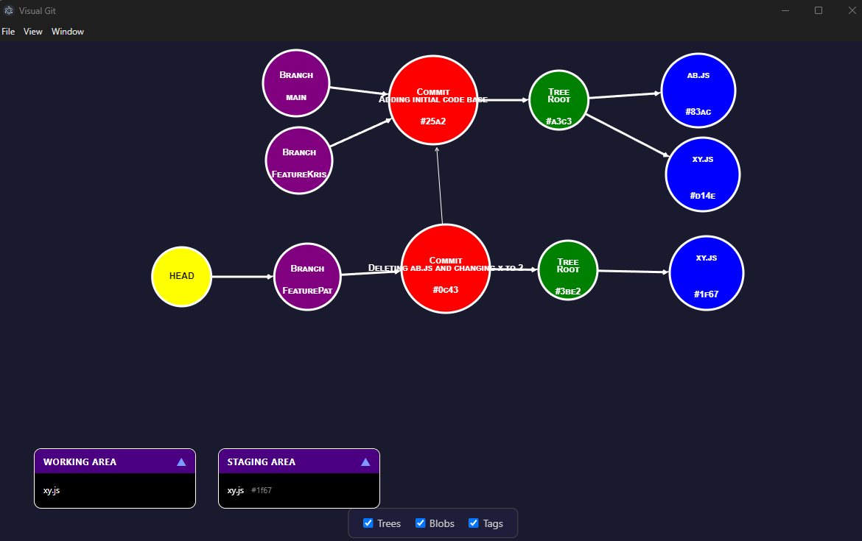
- Now that we can see that Pat’s feature branch only has one file in it while both main and Kris’s branch has both ab.js AND xy.js.
Let’s go ahead and perform Kris’s updates. Changing b -> 20 in ab.js, and renaming the file xy.js to zx.js:
  - 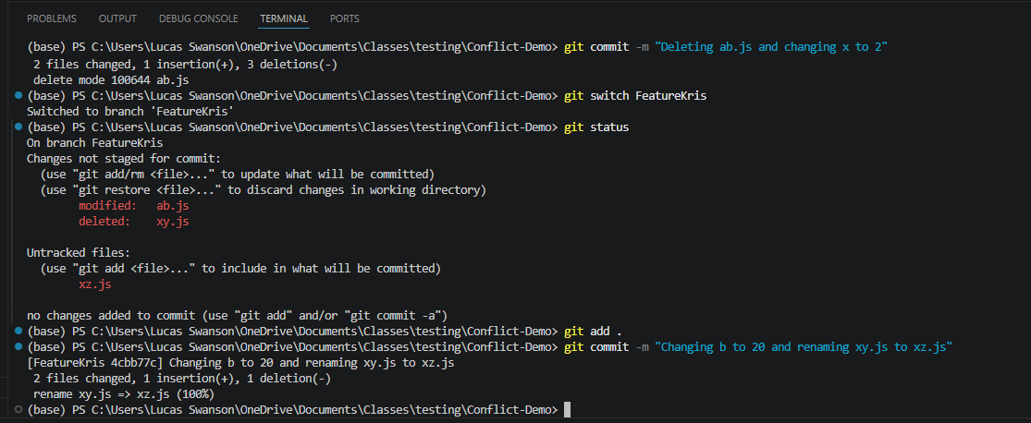
  - 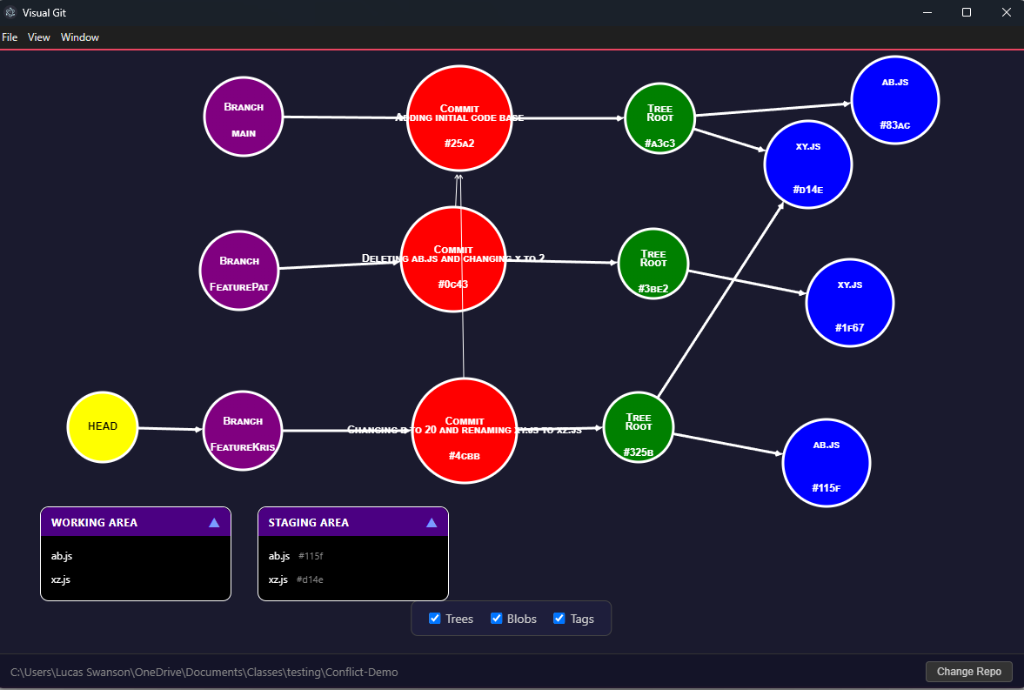
- Now we can see that our three branches are quite unique! Pat only has one file and linked back to the original commit from main, while Kris has two files!
- We will now merge first Pat’s items, then we will try to merge Kris’s branch but we will run into an issue
  - 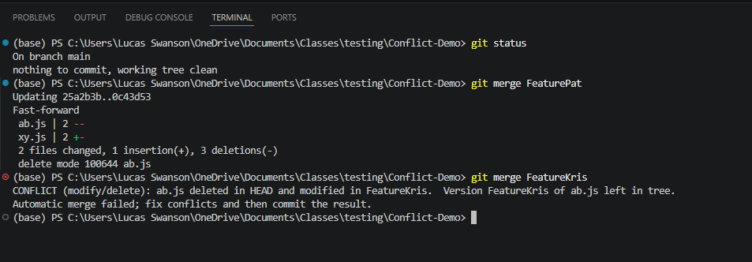
  - 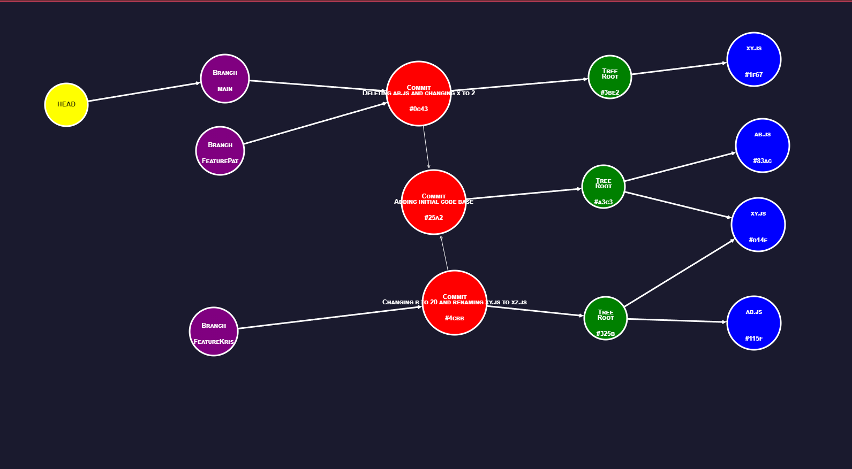
Here we can see that Pat’s branch was merged with main, so main only has one file, xy.js. However Kris’s branch gave us a problem where we need to resolve conflicts in ab.js that was deleted.
- Now to fix this issue, we are actually just going to say “we don’t like Pat, he is mean and his code is bad”. So we are going to have Kris overwrite her branch over what is currently in main:
  - 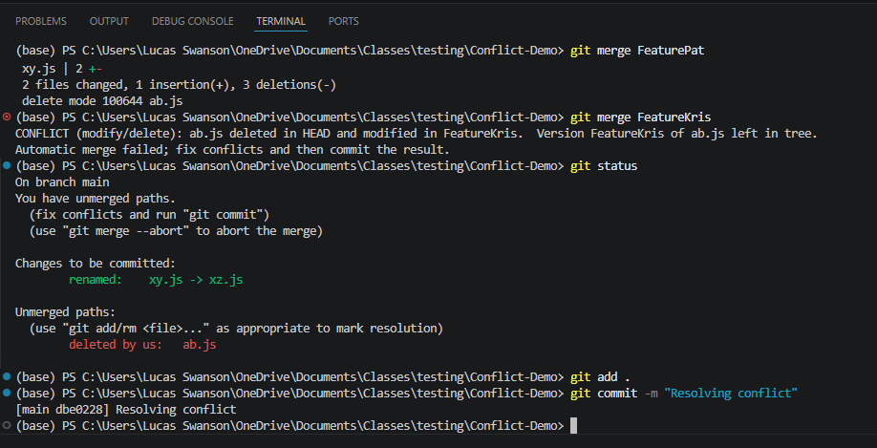
  - 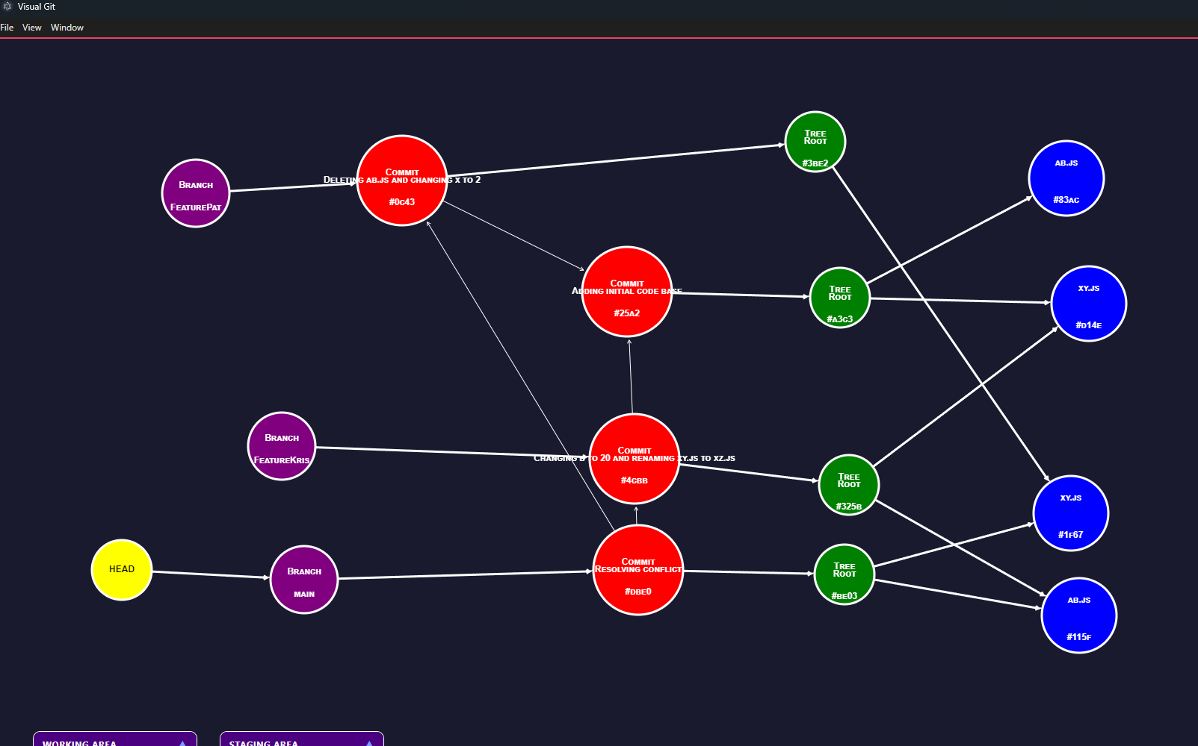
And Kris has solved her git conflict! She kept the changes that she made, changing the value of b in ab.js, and renamed the file xy.js to xz.js by having her commit append to main and pointing the new main conflict commit, tree root to XZ.js and ab.js.

